**eg:Query the information of students.**

select * from student;

**Q1: Query the information and course scores of students whose grades in the "01" course are higher than those in the "02" course**

SELECT st.*, sc1.s_score AS course_01_score

FROM student st

JOIN score sc1 ON st.s_id = sc1.s_id AND sc1.c_id = '01'

JOIN score sc2 ON st.s_id = sc2.s_id AND sc2.c_id = '02'

WHERE sc1.s_score > sc2.s_score;

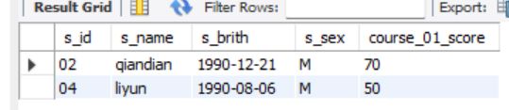

**Q2:** **Query the information and course scores of students whose grades in the "01" course are lower than those in the "02" course**

SELECT st.*, sc1.s_score AS course_01_score

FROM student st

JOIN score sc1 ON st.s_id = sc1.s_id AND sc1.c_id = '01'

JOIN score sc2 ON st.s_id = sc2.s_id AND sc2.c_id = '02'

WHERE sc1.s_score < sc2.s_score;

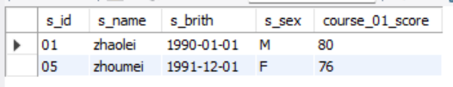

**Q3:** **Query the student number, student name and average score of students whose average score is greater than or equal to 60 points**

SELECT st.s_id, st.s_name, AVG(sc.s_score) AS Average_Score FROM student st

JOIN score sc ON st.s_id = sc.s_id

GROUP BY st.s_id

HAVING Average_Score >= 60;

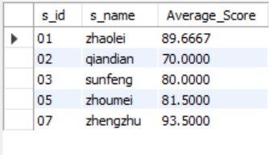

**Q4: Query the student number, name and average score of students whose average score is less than 60 points (including those with and without scores)**

SELECT st.s_id, st.s_name, AVG(sc.s_score) AS Average_Score FROM student st

LEFT JOIN score sc ON st.s_id = sc.s_id

GROUP BY st.s_id

HAVING Average_Score IS NULL OR Average_Score < 60;

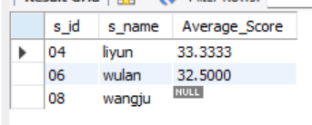

**Q5: Query the student number, student name, total number of courses selected, and total grades of all courses (including those without selected courses) of all students**

SELECT st.s_id, st.s_name, COUNT(DISTINCT sc.c_id) AS total_courses,

SUM(IFNULL(sc.s_score, 0)) AS total_score

FROM student st

LEFT JOIN score sc ON st.s_id = sc.s_id

GROUP BY st.s_id, st.s_name;

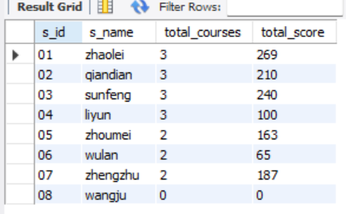

**Q6: Query the number of teachers with the surname "li"**

SELECT COUNT(*) FROM teacher

WHERE t_name LIKE 'li%';

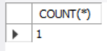

**Q7: Query the information of students who have studied with teacher "zhangsan"**

SELECT st.*

FROM student st

WHERE st.s_id IN (

SELECT DISTINCT sc.s_id

FROM score sc

JOIN course c ON sc.c_id = c.c_id

JOIN teacher t ON c.t_id = t.t_id

WHERE t.t_name LIKE 'zhangsan'

);

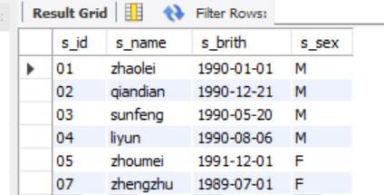

**Q8: Query the information of students who have not studied under teacher "zhangsan"**

SELECT st.*

FROM student st

WHERE st.s_id NOT IN (

SELECT DISTINCT sc.s_id

FROM score sc

JOIN course c ON sc.c_id = c.c_id

JOIN teacher t ON c.t_id = t.t_id

WHERE t.t_name LIKE 'zhangsan'

);

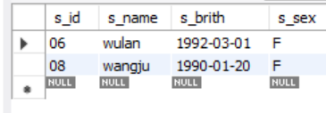

**Q9: Query the information of students who have studied the course numbered "01" and also studied the course numbered "02"**

SELECT st.*

FROM student st

JOIN score sc1 ON st.s_id = sc1.s_id AND sc1.c_id = '01'

JOIN score sc2 ON st.s_id = sc2.s_id AND sc2.c_id = '02';

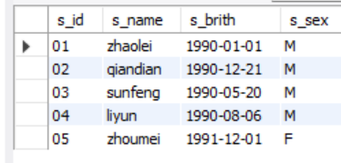

**Q10: Query the information of students who have studied the course numbered "01" but not the course numbered "02"**

SELECT st.*

FROM student st

JOIN score sc1 ON st.s_id = sc1.s_id AND sc1.c_id = '01'

LEFT JOIN score sc2 ON st.s_id = sc2.s_id AND sc2.c_id = '02'

WHERE sc2.s_id IS NULL;

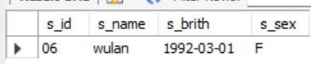

**Q11: Query information about students who have not completed all courses**

SELECT st.* FROM student st

WHERE (SELECT COUNT(DISTINCT c_id) FROM course) >

(SELECT COUNT(DISTINCT c_id) FROM score WHERE s_id = st.s_id);

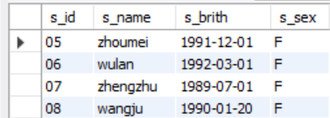

**Q12: Query the information of students who have at least one course that is the same as the student with student number "01"**

SELECT DISTINCT st.*

FROM student st

JOIN score sc ON st.s_id = sc.s_id

WHERE EXISTS (

SELECT 1 FROM score sc2

WHERE sc.c_id = sc2.c_id AND sc2.s_id = '01'

) AND st.s_id NOT LIKE '01';

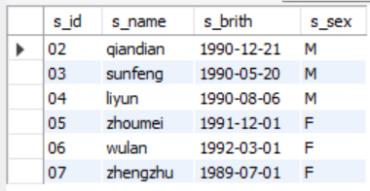

**Q13: Query the information of other students who are studying the same course as the student numbered "01"**

SELECT DISTINCT st.*

FROM student st

JOIN score sc ON st.s_id = sc.s_id

WHERE sc.c_id IN (

SELECT c_id FROM score WHERE s_id = '01'

) AND st.s_id NOT LIKE '01';

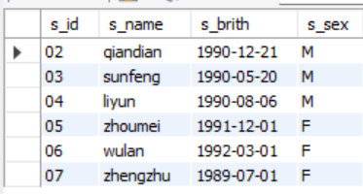

**Q14: Query the names of students who have not studied any course taught by "zhangsan"**

SELECT DISTINCT st.s_name

FROM student st

LEFT JOIN score sc ON st.s_id = sc.s_id

LEFT JOIN course c ON sc.c_id = c.c_id

LEFT JOIN teacher t ON c.t_id = t.t_id AND t.t_name = 'zhangsan'

WHERE t.t_id IS NULL;

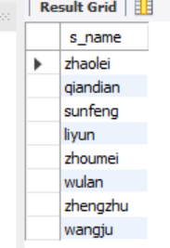

**Q15: Query the student ID number, name and average grade of students who failed two or more courses (Even if you did not take the exam, your score will be recorded as zero, so it should be considered a failure.)**

SELECT st.s_id, st.s_name, AVG(sc.s_score) AS average_grade FROM student st

JOIN score sc ON st.s_id = sc.s_id

WHERE sc.s_score < 60

GROUP BY st.s_id, st.s_name

HAVING COUNT(*) >= 2;

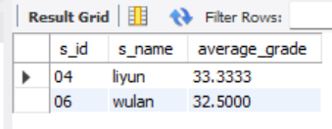

**Q16: Query the student information of "01" course whose score is less than 60 and sorted by score in descending order**

SELECT st.*, sc.s_score FROM student st

JOIN score sc ON st.s_id = sc.s_id

WHERE sc.c_id = '01' AND sc.s_score < 60

ORDER BY sc.s_score DESC;

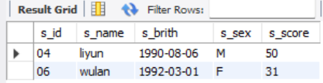

**Q17: Displays the grades for all students in all courses and the average grade by average grade from highest to lowest (Students who did not take the exam will have a score of 0)**

SELECT st.s_id, st.s_name, c.c_id, c.c_name, IFNULL(sc.s_score, 0) AS score,

AVG(IFNULL(sc.s_score, 0)) OVER (PARTITION BY st.s_id) AS average_grade

FROM student st

JOIN course c

LEFT JOIN score sc ON st.s_id = sc.s_id AND c.c_id = sc.c_id

ORDER BY average_grade DESC, st.s_id;

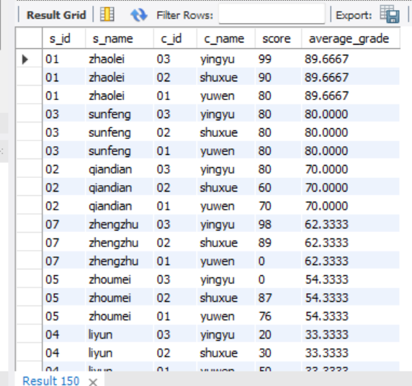

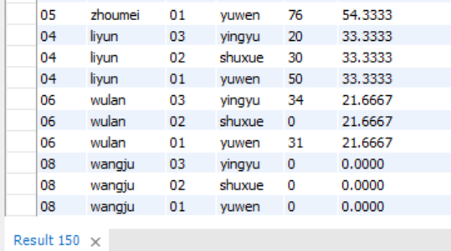

**Q18: Query the highest score, lowest score and average score of each subject: displayed in the following form: course ID, course name, highest score, lowest score, average score, passing rate, medium rate, good rate, excellent rate – passing is >=60 , medium is: 70-80, good is: 80-90, excellent is: >=90**

SELECT c.c_id, c.c_name, MAX(sc.s_score) AS highest_score, MIN(sc.s_score) AS lowest_score,

AVG(sc.s_score) AS average_score, COUNT(CASE WHEN sc.s_score >= 60 THEN 1 END) / COUNT(*) AS passing_rate, COUNT(CASE WHEN sc.s_score >= 70 AND sc.s_score < 80 THEN 1 END) / COUNT(*) AS medium_rate,

COUNT(CASE WHEN sc.s_score >= 80 AND sc.s_score < 90 THEN 1 END) / COUNT(*) AS good_rate, COUNT(CASE WHEN sc.s_score >= 90 THEN 1 END) / COUNT(*) AS excellent_rate

FROM student st

JOIN score sc ON st.s_id = sc.s_id

JOIN course c ON sc.c_id = c.c_id

GROUP BY c.c_id, c.c_name;

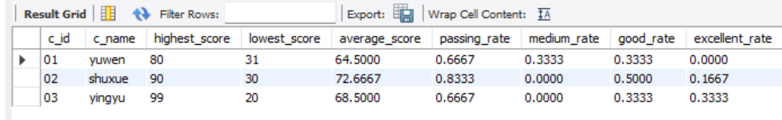

**Q19: Query the student information, Sort by the scores of each subject and display the ranking**

SELECT st.*, c.c_id, c.c_name, sc.s_score,

(SELECT COUNT(*) + 1 FROM score sc2

WHERE c.c_id = sc2.c_id AND sc2.s_score > sc.s_score) AS ranking

FROM student st

JOIN score sc ON st.s_id = sc.s_id

JOIN course c ON sc.c_id = c.c_id

ORDER BY c.c_id, ranking;

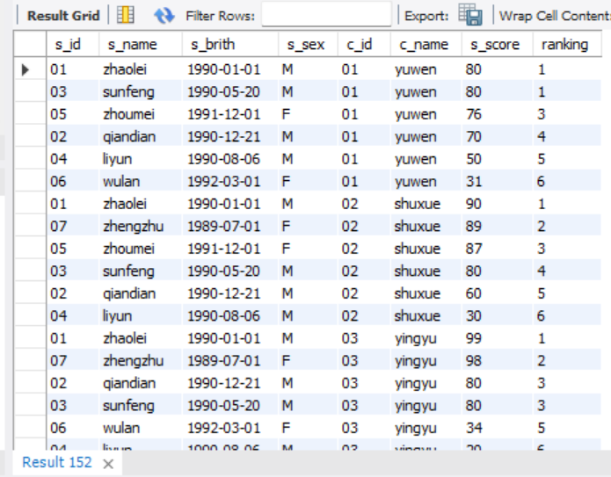

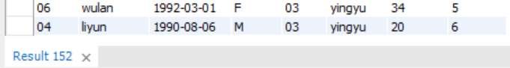

**Q20: Query students’ total scores and rank them**

☹